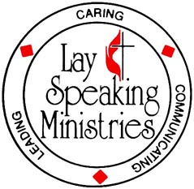

LAY SPEAKING MINISTRIES

Application for Lay Speaking Class

THE HARRISONBURG DISTRICT

THE VIRGINIA CONFERENCE OF THE UNITED METHODIST CHURCH
Advanced ClassSaturday, September 25, 2010 ~ 8 am to 6 pm
Asbury UMC, Harrisonburg, VA
Cost $ 15⁰⁰

Part 1a – Personal Data
NAME: ________________________________________
STREET: ________________________________________
APT #: ________________________________________
CITY: ___________________________________ STATE: Virginia ZIP: _______________
Home Phone: _________________________ Work Phone: _________________________
E-Mail: _________________________________________

Part 1b –Church Data
CHARGE: ___________________________________
STREET: ________________________________________
STATE: Virginia ZIP: _________________

CHURCH NAME: _____________________________
CITY: _____________________________
PHONE: ________________________________

Part 2 – Request of the Lay Speaking Minister
I hereby request recommendation of my pastor &/or the PPR Committee Chair to be a Certified Lay Speaker or Recertification.

(Date) _______________________________ (signed) _______________________________________

Part 3 – Recommendation of the PPR Committee
The PPRC recommends concurrence with the request of this person to be a Certified Lay Speaker or Recertification.

(Date) _______________________________ (signed) _______________________________________
Chairperson

Part 4 – Recommendation of the Pastor
I recommend concurrence with the request of this person to be a Certified Lay Speaker or Recertification.
(Date) ________________ (signed) _______________________________________

Part 5 – Completion of Advanced Lay Speaking Class –Titled_________________________________________________

(Date) ________________ (signed) _______________________________________
Instructor

Mail or Email completed form to : Rev. Bob Talbot ~205 South Main St., Harrisonburg, VA 22801 Or Email Bob :
btalbott@asburyumc.cc Phone: 540-434-2836

